Pranavsing Thakur

240840325037

Question 1:

2.

select ae.name , count(distinct(r.src_airport_id,'-',r.dest_airport_id)) from airline ae join route r on ae.airline_id=r.airline_id group by ae.name order by count(distinct(r.src_airport_id,'-',r.dest_airport_id)) desc limit 3;



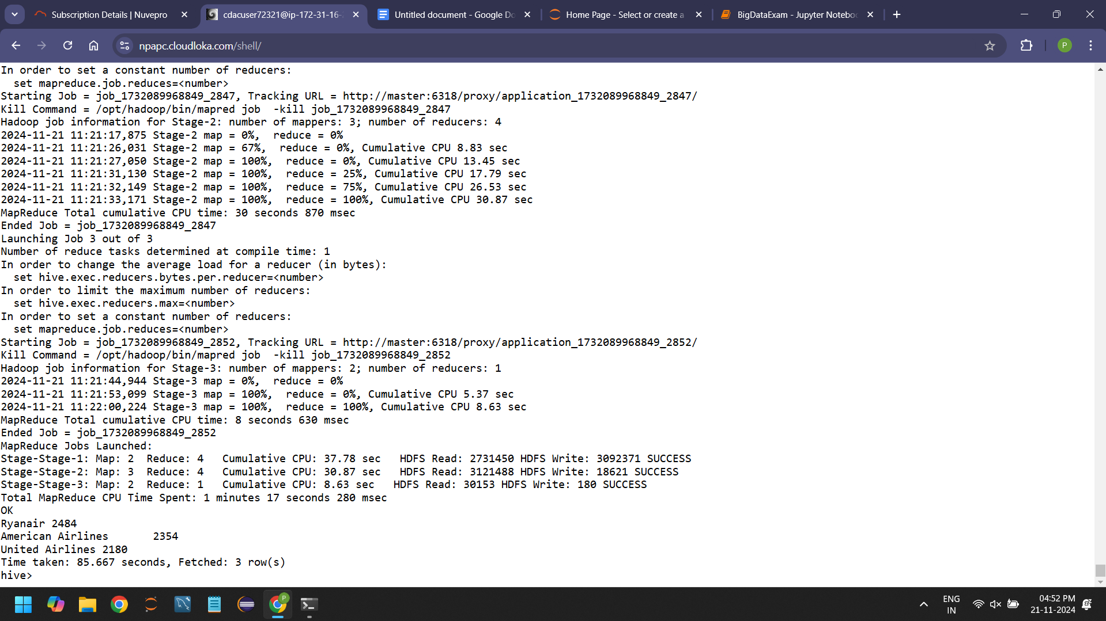

3.

select distinct equipment from route limit 10;



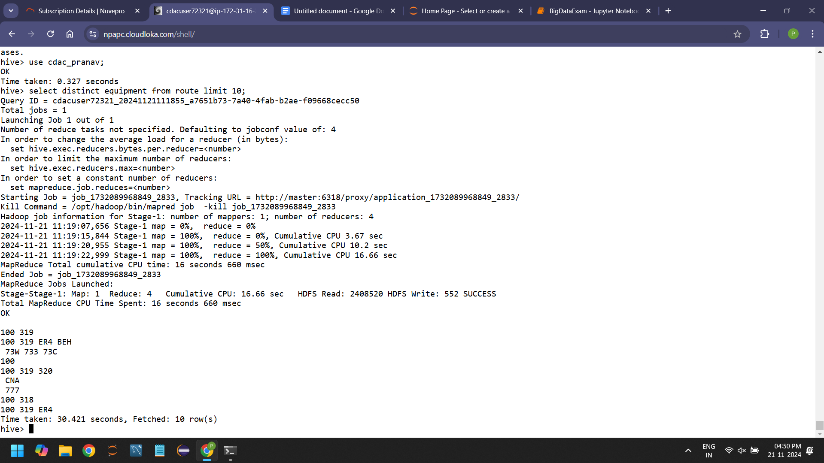

1.

Question 2:

1.

create table routes_partitioned(airline_iata string, airline_id int, src_airport_iata string, src_airport_id int, dest_airport_id int, codeshare string, stops int, equipment string)

> partitioned by (dest_airport_iata string)

> row format delimited

> fields terminated by ','

> stored as textfile;

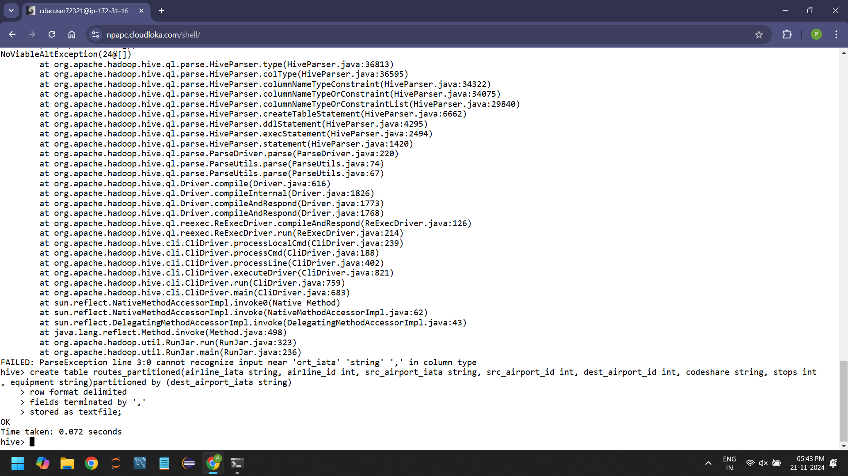

2.

insert overwrite table routes_partitioned partition(dest_airport_id) select a.airline_iata, a.airline_id, a.src_airport_iata, a.src_airport_id, a.dest_airport_id, a.codeshare, a.stops, a.equipment, a.dest_airport_id from route a distribute by dest_airport_id;

Cant upload screenshot because processing is taking to much time hive is slow

SPARK

Question 1:

1.

df.agg(avg("booked_seats"),min("booked_seats"),max("booked_seats")).show()

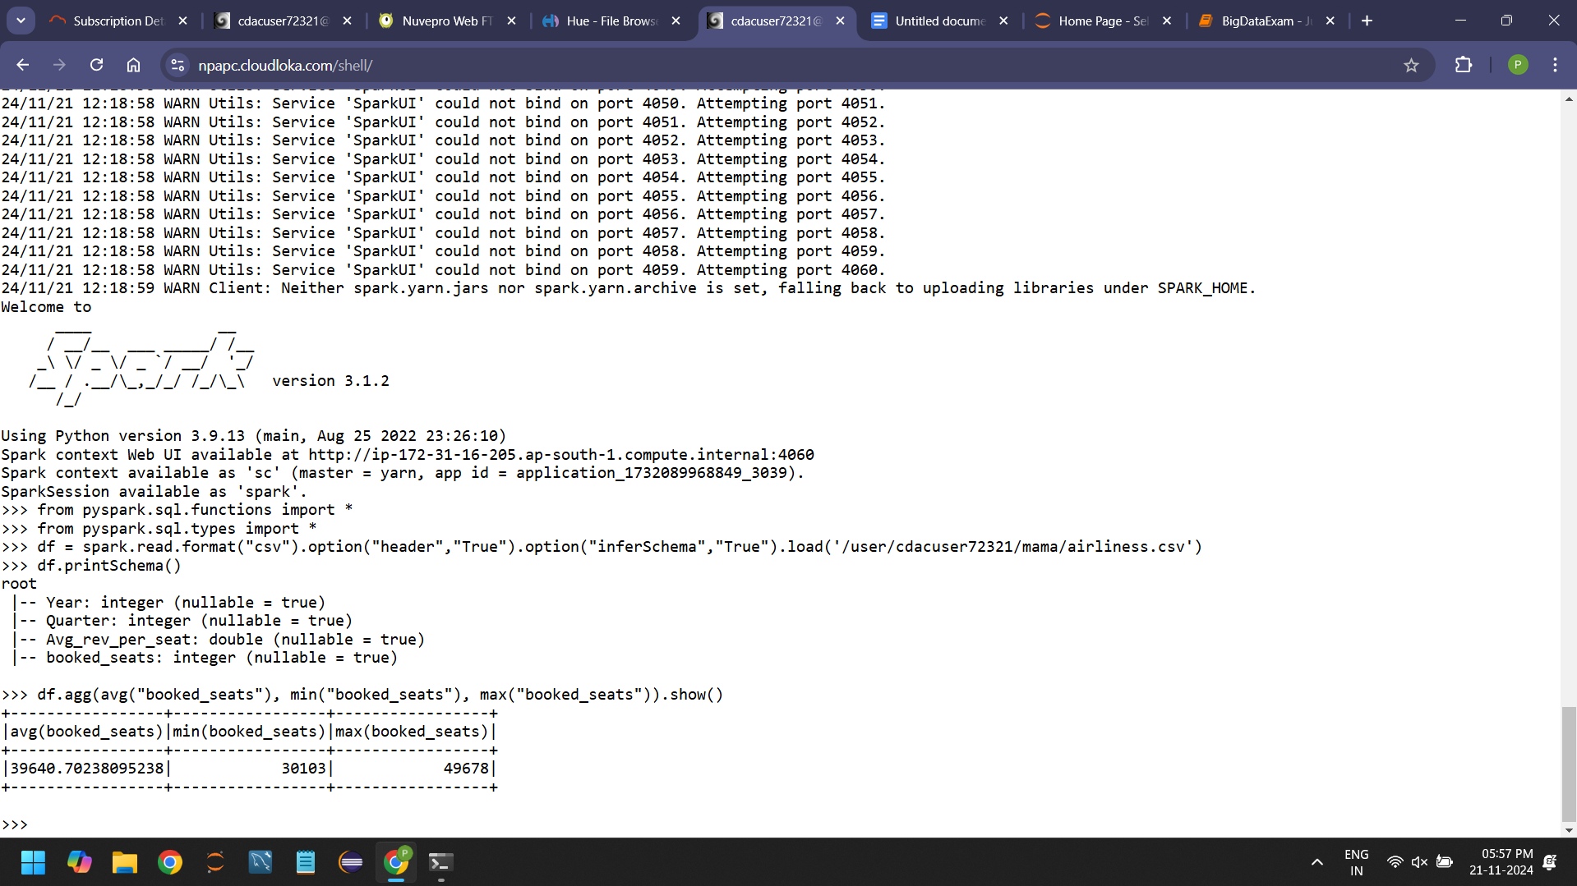

3.

df.groupBy("Quarter").avg("booked_seats").show()



4.

df.groupBy("Year").agg(count("Year")).show()

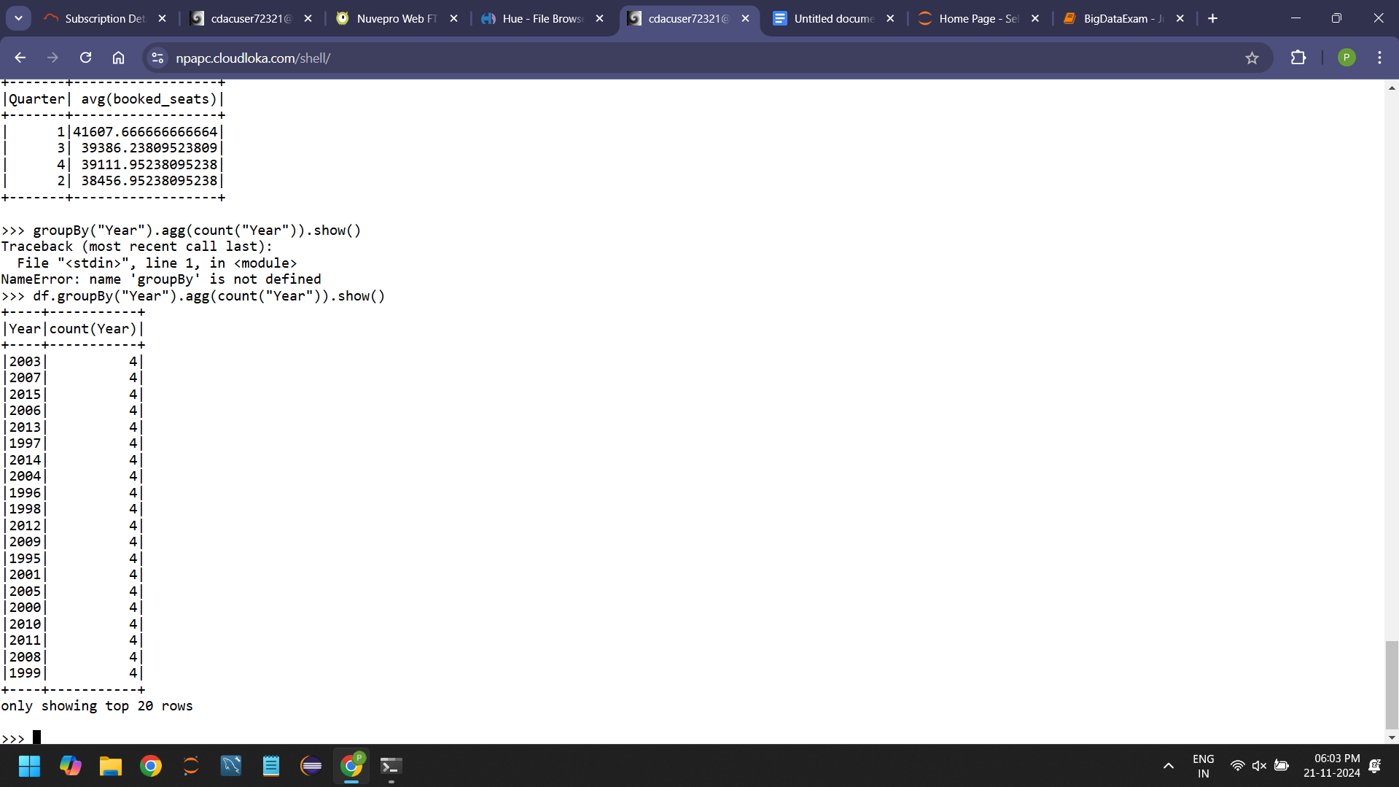

5.

df.groupBy("Year","Quarter").agg(sum(col("avg_rev_per_seat")*col("booked_seats")).alias("total_revenue")).orderBy("total_revenue",ascending=True).limit(1).show()

